The goal of this activity is to assess your approach, consideration and processing of some fairly simple data. Do not take more than 4 hours, and feel free to leave portions open-ended and/or undocumented. We will review and you will have an opportunity to clarify all parts.

Lastly, don’t be too critical of code style or performance. Think of this as a quick proof-of-concept and not a production ready process!

Part 1:

The [GHTorrent](https://ghtorrent.org/) project has been scraping Github commit data for a while now. Downloads of their data from MySQL or MongoDB is available here - <https://ghtorrent.org/downloads.html>

Grab the most recent database dump from the link above and run some basic statistics on the data, showing the following:

Explanation:

1. So firstly, I had setup a MySQL instance in Cloud SQL
2. Created user for BigQuery to connect
3. Created database
4. Connect to it using following command

gcloud sql connect mycloudsql --user=root –quiet

1. Setup the tables from GHTorrent

* Top 5 repos by commit activity (# of commits)

**Query:**

select u.id as user_id, count(*) as count_of_commits

from ghtorrentmysql1906.MySQL1906.commits c, ghtorrentmysql1906.MySQL1906.users u

where c.author_id = u.id

group by u.id

order by count_of_commits desc

limit 5



* Top 5 most frequent words used in the commit messages

**Query:**

SELECT * FROM(

SELECT

REGEXP_EXTRACT(body, r"^[a-zA-Z]+")

AS most_frequent_words,

COUNT(*) AS Appearance_of_words,

FROM plasma-block-285519.ghtorrent.commit_comments

WHERE body IS NOT NULL

GROUP BY most_frequent_words

ORDER BY Appearance_of_words DESC)

WHERE most_frequent_words IS NOT NULL

limit 5;



* Both of the above sliced by year, i.e. “Top 5 repos for 2019”

**Query:**

SELECT * FROM (select u.id as user_id, EXTRACT(YEAR FROM u.created_at) AS year,count(*) as count_of_commits

from ghtorrentmysql1906.MySQL1906.commits c, ghtorrentmysql1906.MySQL1906.users u

where c.author_id = u.id

group by u.id, year

order by count_of_commits desc)

where year = 2019

limit 5



SELECT * FROM(

SELECT

REGEXP_EXTRACT(body, r"^[a-zA-Z]+")

AS most_frequent_words,

EXTRACT(YEAR FROM created_at) AS year,

COUNT(*) AS Appearance_of_words,

FROM plasma-block-285519.ghtorrent.commit_comments

WHERE body IS NOT NULL

GROUP BY most_frequent_words, year

ORDER BY Appearance_of_words DESC)

WHERE most_frequent_words IS NOT NULL

AND year = 2019

limit 5;



Hint: Some code to get you started on this data is here - <https://github.com/src-d/datasets/tree/master/CommitMessages>, and some more to get you thinking about approach here - <https://gist.github.com/paulmillr/2657075>

Part 2:

Continuing on what you played with in Part 1, but now for more up-to-date statistics, you will pull in some data from the Github API <https://docs.github.com/en/rest/reference/repos#statistics>

Using the repository for Vue.js(<https://github.com/vuejs/vue>), get the following:

* All of 2020’s commit activity (<https://docs.github.com/en/rest/reference/repos#get-the-last-year-of-commit-activity>)

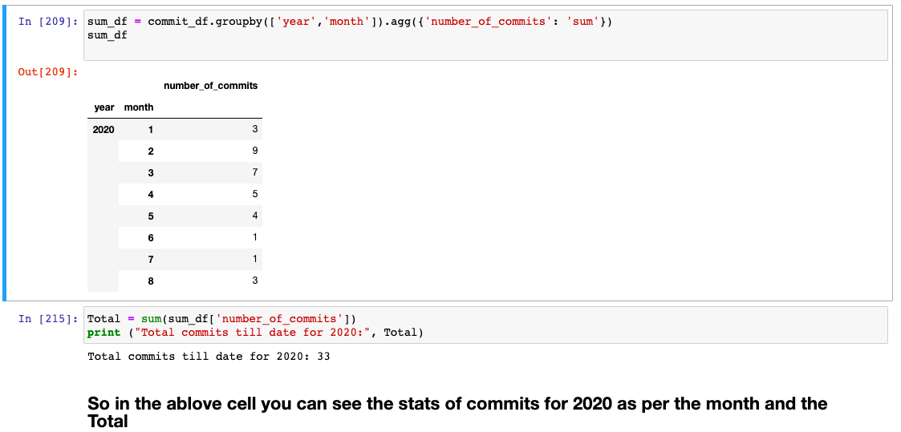

* Most active contributor in terms of commits (<https://docs.github.com/en/rest/reference/repos#get-all-contributor-commit-activity>

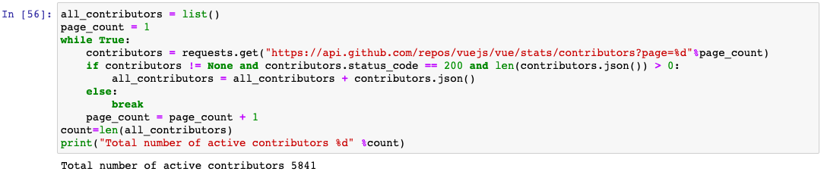

For both parts, it is up to the individual to determine how they’d like to display the data. It should be presented in human-readable form but does not need to be “pretty”.

Please package all your code and outputs into a zip file once complete. You may also commit it to a GitHub repo if that’s more convenient.

GitHub Link: <https://github.com/SayaliBhagat/Github_user_commit_activity_using_API_Python>